Nicholas Skinner

CS321

Fall 2019

Homework 2

1. **Convert the following NFA into an equivalent DFA**

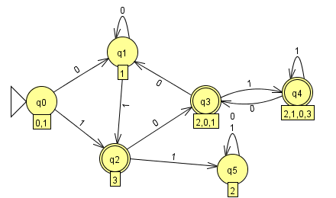

This is an equivalent DFA, as it captures each possible state that the NFA will encounter. Each state has an output for both 1 and 0. One trap state is needed, as q3 from the NFA has no 1 output.

1. **Show that the language L = { vwv : v, w {a,b}*, |v| = 2} is a regular language**

An NFA will display that the language is a regular language. The following is an NFA for this problem:

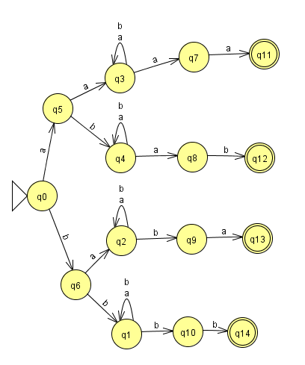

This problem has the |V|, which I believe is a sequence of a,b that will need to be repeated at the end. I chose an NFA to represent the problem as I believe it made it a lot more readable.

1. **Prove that if L is regular language then L R is a regular language.**

Let E = 01* + 10*.

E^R = (01* + 10*)R = (01*)R + (10*)R

= (1*)^R 0^R + (0*)^R 1^R

= (1^R)*0 + (0^R)*1

= 1*0 + 0*1.

Effectively, this is just saying that the composition of this reversed language is a regular language. And it is spelled out through the solution

1. **Give regular expressions for the following languages on = {a, b}** 
   1. **L1 = { w : na(w) mod 3 = 1}.**

(a)((b)*(a)(b)*(a)(b)*(a)(b)*)*

Requires at least 1 a, then 3 for every subsequent sequence

* 1. **L2 = { w : w ends in aa }.**

(a+b)*(aa)

Infinite a’s or b’s, but must end in aa

* 1. **L3 = all strings containing no more than three a’s**

(b)*(a+λ)(b)*(a+λ)(b)*(a+λ)(b)*

Checks for at most 3 a’s and any number of b’s if an a is not needed, lambda is used in its place.

1. **Consider a type of scientific notation for real numbers with the following rules:** 
   1. **A number can be preceded by a “+” or “-“ sign or the sign may be absent.**
   2. **Numeric values must be of the form cb1b2…bn where bi is any digit, but c must be nonzero**
   3. **The number may be followed by an exponent field of the form e”+” y1y2 or e”-“y1y2, where yi can be any digit {0, 1, 2, 3, 4, 5, 6, 7, 8, 9}.**

(‘+’ + ‘-’ + λ) (1+2+3+4+5+6+7+8+9)(1+2+3+4+5+6+7+8+9+0)*(((‘e’)(‘+’ + ‘-’ + λ) (1+2+3+4+5+6+7+8+9+0)(1+2+3+4+5+6+7+8+9+0))+λ)

From the way the question was phrased, the exponential seemed to be optional, considering it said “ -123e+10 and 257 represent real number in this scientific format.” I understand that to mean the exponent is optional.

1. **Find a regular grammars for the following languages on ={a, b}:**
   1. **L0 is all strings with exactly one a**

b* a b*

Right Align regular:

B->aC | bB | λ

C->aC | bC

A->aC | bB | λ

S->aA | bB

* 1. **L1 = { w : na(w) mod 3 = 1}.**

S->bS | aA

A-> bA | aB | λ

B->bB | aS